Packaged Model Instructions
The packaged model is saved as xgboost_model.pkl file and can be loaded directly into any Python environment using the pickle package. Once loaded, the model works exactly the same way it did during training: it expects a DataFrame containing the same feature columns that were used to train it. To make this easy, I saved the full list of feature names separately as feature_columns.pkl, so a developer can always reconstruct the correct input structure.
To run predictions, the developer simply needs to load both files, prepare the input data using the saved feature list, and pass it into the model’s predict() function. Any feature that is missing for a particular application should be left as NaN — XGBoost handles missing values natively, so no manual filling is required. The model returns a clean binary output:
- 1 for high-risk applications
- 0 for low-risk applications
A small sample script is included to demonstrate how to load the model, prepare a few rows of data, and generate predictions. This makes it straightforward for another developer to integrate the model into a wider system.

Data Preparation Summary
The raw dataset was provided in a sparse format, where each row began with a risk score followed by only the features that were present for that application. I parsed each row into a dictionary and allowed pandas to expand it into a full table. Any feature that didn’t appear in a row naturally becomes a missing value (NaN). This is intentional — XGBoost handles missing values internally by learning a default direction for them, so there is no need to manually fill zeros.
After expanding the data, I used the provided mapping file to replace the feature numbers with meaningful feature names. I then created a binary label called risk_indicator by converting the continuous risk score into two categories: scores below 0.30 were marked as low risk, and scores at or above 0.30 were marked as high risk.
Before training the model, I removed duplicate rows. Because the same application can appear in multiple monthly files, duplicates could end up in both the training and validation sets, which would artificially inflate performance. Removing them ensures that the validation set contains only unseen data, giving a fair and honest evaluation of the model.
The final processed dataset was saved as processed_data.csv and used as the input for model training.

Model Summary
For this project, I chose an XGBoost classifier because it performs extremely well on high-dimensional, sparse datasets like this one. It handles missing values internally, copes well with large numbers of features, and is designed to capture complex patterns without requiring heavy manual tuning. All of the processed feature columns were included in the model, and the dataset was split into an 80/20 train–test split to ensure that performance was evaluated on data the model had not seen before.
The model achieved the following performance on the validation set:
Precision: 0.932 = (93.2%)
Recall: 0.982 = (98.2%)
These validation-split figures represent the model’s true generalisation performance; the full-dataset evaluation in model_testing.py is included only as a sanity check.
The model achieved strong results, with both precision and recall comfortably above the required 90% threshold. This means the model is reliable at identifying high-risk applications while keeping false positives low.
A feature-importance plot showing the Top 15 most influential features was generated during training and saved as plots/feature_importance_top15.png as shown below. This provides a clear summary of which behavioural features contribute most strongly to the model’s predictions.
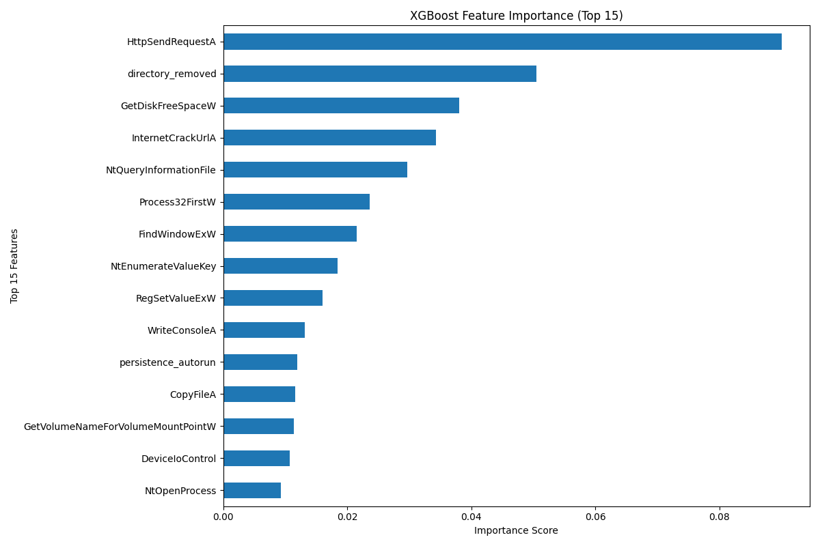
The trained model was saved using the standard Python pickle package. The exact list of feature columns used during training was also saved (feature_columns.pkl) to ensure that any deployment environment can reconstruct the correct input structure.

